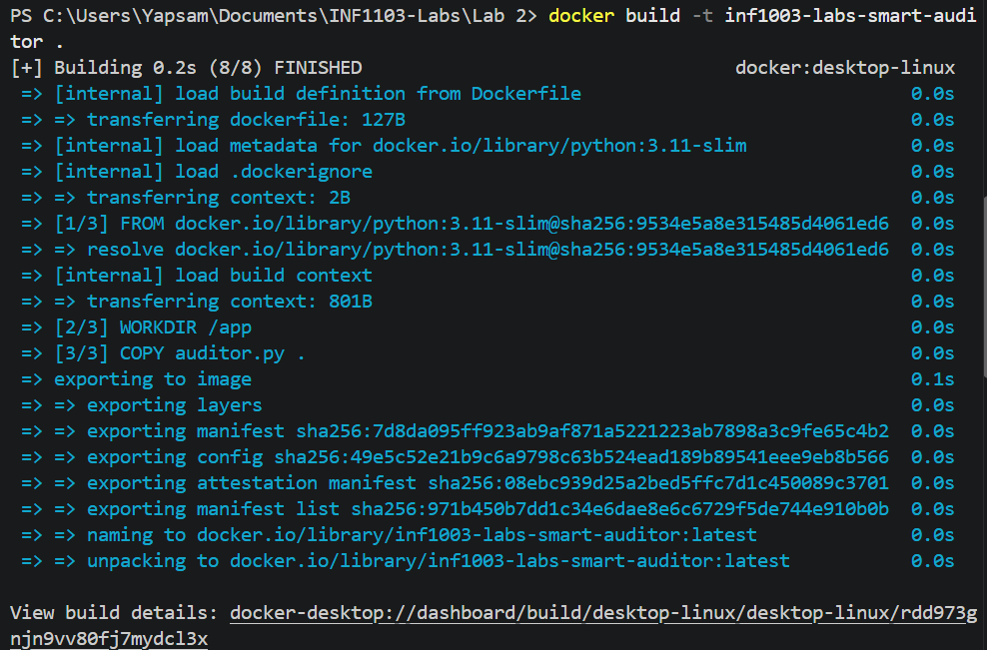
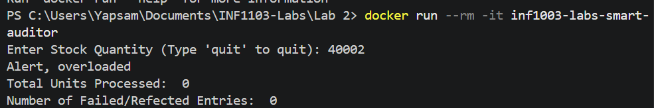
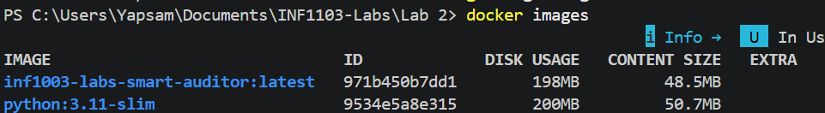
Git Link: https://github.com/YapsamSIT/inf1103-labs

